**Data Description**

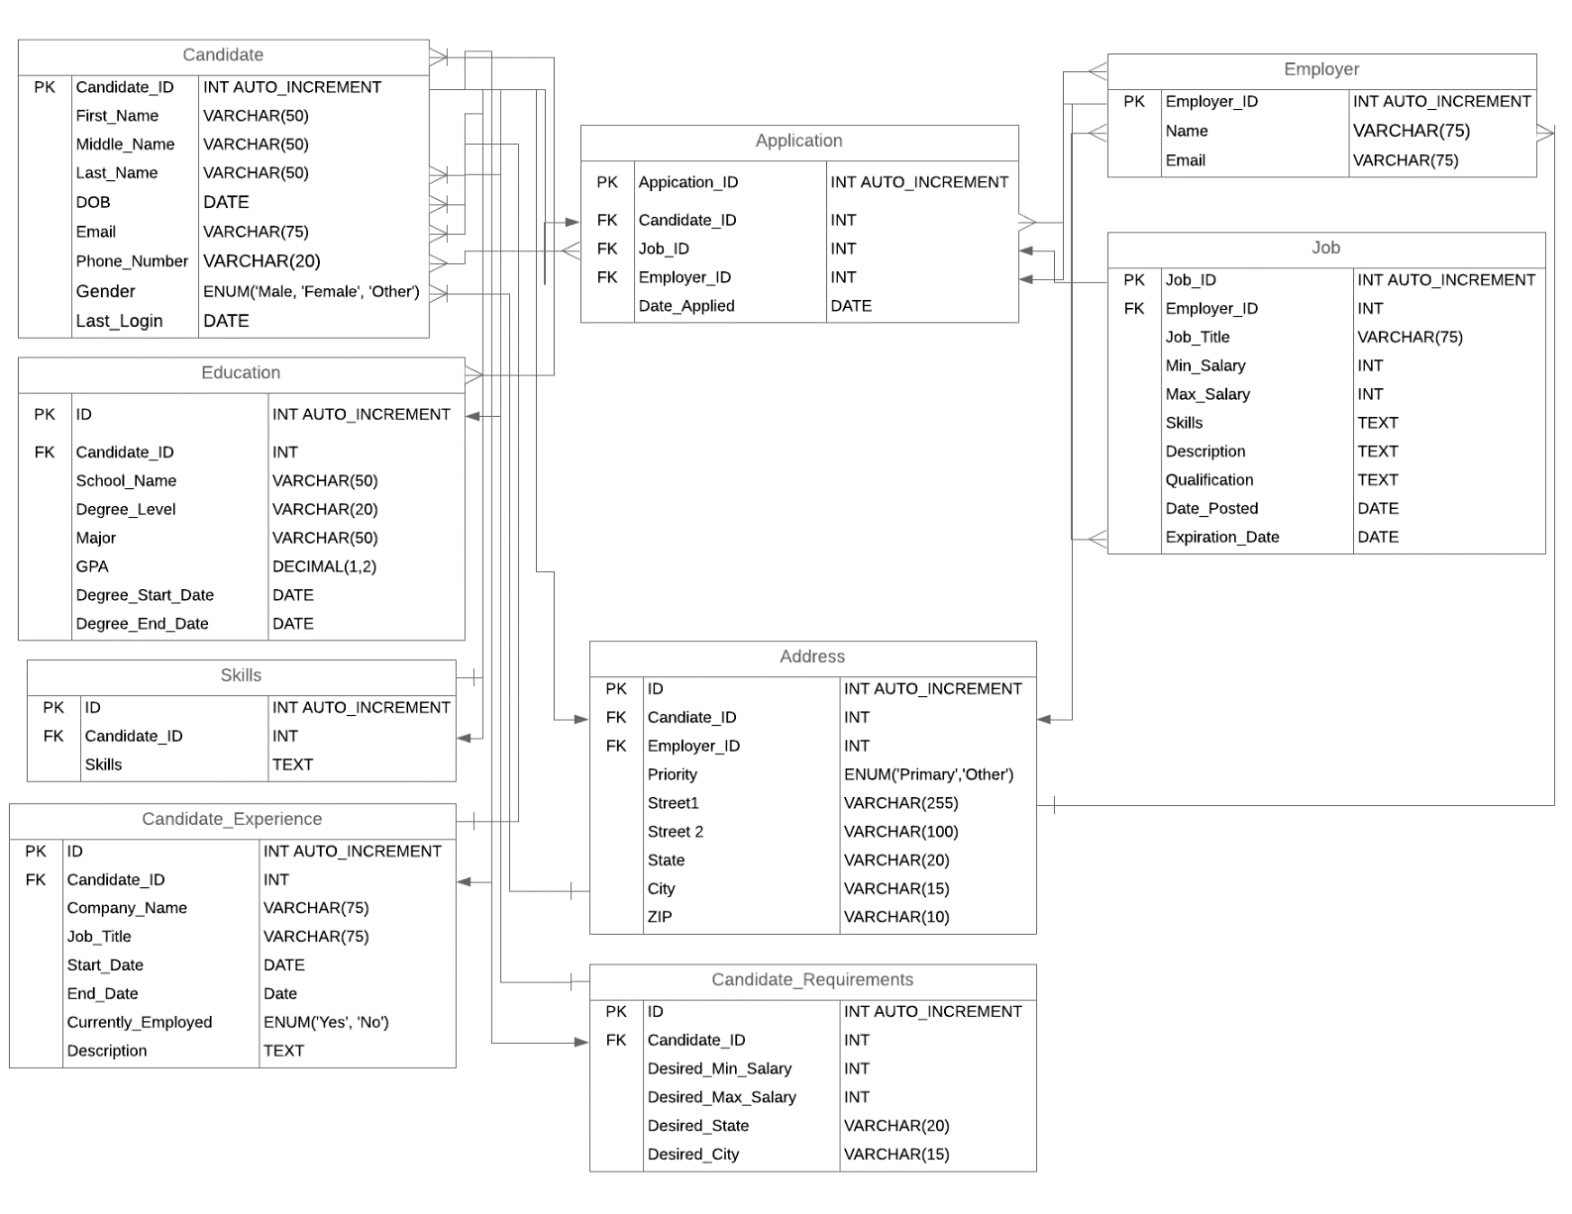

**Candidate:**

* Candidate_ID – Each candidate will have a unique candidate ID which will be used for indexing (Private key). Datatype: INT
* First_Name – Candidates first name. Datatype: VARCHAR (50)
* Middel_Name – Candidates middle name. Datatype: VARCHAR (50)
* Last_Name – Candidates last name. Datatype: VARCHAR (50)
* DOB – Candidates date of birth in YYYY/MM/DD Format. Datatype: DATE
* Email – Candidates email address. Datatype: VARCHAR (75)
* Phone_Number – Candidates phone number. Datatype: VARCHAR (20)
* Gender – Candidates gender. Datatype: ENUM (‘Male’, ‘Female’, ‘Other’)
* Last_Login – Recent timestamp. Datatype: DATE

**Education:**

* ID – Unique ID which will be used for indexing (Private key). Datatype: INT
* Candidate_ID – Candidate ID which will be used for indexing (Foreign key). Datatype: INT
* School_Name – Candidates school/university name. Datatype: VARCHAR (50)
* Degree_Level – Degree level (example: M.S, B.S, PhD). Datatype: VARCHAR (20)
* Major – Major name. Datatype: VARCHAR (50)
* GPA - Grade point average. Datatype: Decimal (1.2)
* Degree_Start_Date: Degree start date in YYYY/MM/DD Format. Datatype: DATE
* Degree_End_Date: Degree end date in YYYY/MM/DD Format. Datatype: DATE

**Skills:**

* ID – Unique ID which will be used for indexing (Private key). Datatype: INT
* Candidate_ID – Candidate ID which will be used for indexing (Foreign key). Datatype: INT
* Skills– Candidates Technical and other skills. Datatype: TEXT

**Work Experience:**

* ID – Unique ID which will be used for indexing (Private key). Datatype: INT
* Candidate_ID – Candidate ID which will be used for indexing (Foreign key). Datatype: INT
* Company_Name – Company name. Datatype: VARCHAR (75)
* Job_Title – Job title. Datatype: VARCHAR (75)
* Degree_Start_Date – Job start date in YYYY/MM/DD Format. Datatype: DATE
* Degree_End_Date – Job end date in YYYY/MM/DD Format. Datatype: DATE
* Currently_Employed – If the candidate is still working. ENUM (‘Yes, ‘No’)
* Description – Job description

**Candidate Requirements:**

* ID – Unique ID which will be used for indexing (Private key). Datatype: INT
* Candidate_ID – Candidate ID which will be used for indexing (Foreign key). Datatype: INT
* Desired_Min_Salary – Minimum expected salary. Datatype: INT
* Desired_Max_Salary – Maximum expected salary. Datatype: INT
* Desired_State – Prefered state. VARCHAR (20)
* Desired_City – Prefered city. VARCHAR (15)

**Employer:**

* Employer_ID – Unique Employer ID which will be used for indexing (Private key). Datatype: INT
* Name – Employer name. Datatype: VARCHAR (75)
* Email – Employer email ID. Datatype: VARCHAR (75)

**Job:**

* Job_ID – Unique ID which will be used for indexing (Private key). Datatype: INT
* Employer_ID – Employer ID which will be used for indexing (Foreign key). Datatype: INT
* Job_Title – Job title. Datatype: VARCHAR (75)
* Min_Salary – Minimum salary. Datatype: INT
* Max_Salary – Maximum salary. Datatype: INT
* Skill – Required skills. Datatype: TEXT
* Description – Job description. Datatype: TEXT
* Qualification – Required qualification for the job. Datatype: TEXT
* Date_Posted – Job posted date in YYYY/MM/DD Format. Datatype: DATE
* Expiration_Date – Job expiration date in YYYY/MM/DD Format. Datatype: DATE

**Application:**

* Application_ID – Unique ID which will be used for indexing (Private key). Datatype: INT
* Candidate_ID – Candidate ID which will be used for indexing (Foreign key). Datatype: INT
* Job_ID – Job ID which will be used for indexing (Foreign key). Datatype: INT
* Employer_ID – Employer ID which will be used for indexing (Foreign key). Datatype: INT
* Date_Applied – Job applied date in YYYY/MM/DD Format. Datatype: DATE

**Address:**

* ID – Unique ID which will be used for indexing (Private key). Datatype: INT
* Candidate_ID – Candidate ID which will be used for indexing (Foreign key). Datatype: INT
* Employer_ID – Employer ID which will be used for indexing (Foreign key). Datatype: INT
* Priority – Address type. Datatype: ENUM (‘Primary’, ‘Other’)
* Street1 – Street address. Datatype: VARCHAR (255)
* Street2 – Street address (Optional). Datatype: VARCHR (100)
* State – State name. Datatype: VARCHR (20)
* City – City name. Datatype: VARCHR (15)
* Zip – Zip address. VARCHAR (10)